6/27/22

- Here we are in the last week of June, with the July 4th Holiday next Monday, marking the traditional halfway point of Summer. Many of you will take some time off during the next 2 weeks to enjoy vacations or just some well-deserved downtime. Then it is full steam ahead into August with school starting back, the return of football season and the increase in business that we always get during the Fall and Winter months. Will we see any relief in food and fuel prices anytime soon? Most economists agree that inflation will remain high through the rest of this year and into 2023, with a very gradual relaxing of prices during that time. The trick will be getting inflation under control without sending us into a recession, which the Fed is attempting to do now by raising interest rates. How it will play out remains to be seen. Keep your menu prices current and compare your prices to other chains and independent restaurants in your area.
Here is a festive Holiday pizza recipe: JULY 4TH PIZZA
5 oz. Baby spinach chopped 2 garlic cloves smashed
2 TBSP olive oil ½ tsp Salt
Dough for a large pizza 10-12 oz pizza cheese
Pizza sauce 28-32 slices Pepperoni
Roll out dough into a rectangle. Add sauce, then cover with cheese. Make 3 stripes lengthwise with pepperoni slices cut in half. Leave room at top left corner for the spinach mixture, made by sauteing the spinach and next 3 ingredients until spinach is wilted. Place in corner and dot with cheese. Bake and cut into squares.
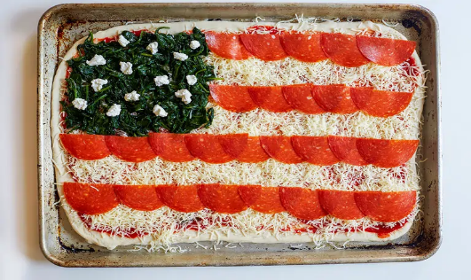
Thank you for your business and have a great 4th Of July!! The Staff of All Original Foods

